**19l-1316**

**Hafiz Ahmad**

**EE-2A**

**Experiment No.12**

Character Arrays and Arrays with Functions

**OBJECTIVE:** To be able to work with character arrays.

To be able to understand the working of arrays with functions.

**String and Character array**

String is a sequence of characters that is treated as a single data item and terminated by null character ‘\0’. Remember that C language does not support strings as a data type. A string is actually one dimensional array of characters in C language. These are often used to create meaningful and readable programs.

**Q NO 1:**

Write a C++ program that asks the user to enter a phrase and then a single letter. The program should then report how many times that letter occurred in the phrase, displaying the letter with double quotes

around it. An example is shown below where the user searched for lower-case "r". Your program should use functions appropriately

#include <iostream>

#include <cstring>

using namespace std;

int main()

{

char x,y[50];

int counter=0;

cout<<"enter the sentence"<<endl;

cin.getline(y,100,'\n');

cout<<"enter the letter"<<endl;

cin>>x;

for(int i=0;i<strlen(y);i++)

{

if(y[i]==x)

{counter++;}

}

cout<<x<<" "<<"repeats"<<" "<<counter<<" "<<"times"<<endl;

return 0;

}

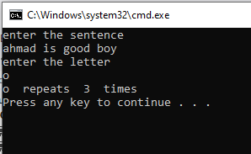

**Q NO2:**

**Write a program that will find the number of vowels in the string. Define a function that must take the whole string from the main and print the number of vowels appears in the string.**

**Example:**

**Input: hard work is a key to success. Output: 8**

#include <iostream>

#include <cstring>

using namespace std;

int vowel(char a[50])

{

int counter=0;

for(int i=0;i<strlen(a);i++)

if(a[i]=='a'||a[i]=='e'||a[i]=='i'||a[i]=='o'||a[i]=='u'||a[i]=='A'||a[i]=='E'||a[i]=='I'||a[i]=='O'||a[i]=='U')

counter++;

return counter;

}

int main()

{

char z[50];

int c;

cout<<"Enter the sentence"<<endl;

cin.getline(z,50,'\n');

c=vowel(z);

cout<<"number of vovels are"<<" "<<c<<endl;

return 0;

}

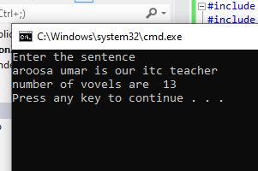

**Q NO 4:**

**Write a function PickLarger( ) which compares the corresponding elements of array, picks the larger element among them and saves the larger element in the output array.**

**Sample Input and Output:**

**Post Lab**

**Encryption can be very useful method for protecting sensitive data from intruders. Data is converted into meaningless form by the usage of a given key and it is converted back to original form by utilizing the key again when required. You need to design an encryption\decryption application.**

**Example:**

**Input: Array 1: 1 2 1 5 9 1 3 5 Array 2: 8 2 1 0 11 10 3 4**

**Output: Output Array: 8 2 1 5 11 10 3 5**

#include <iostream>

#include <cstring>

using namespace std;

void larger(int x[],int y[],int z[],int l)

{

for(int m=0;m<l;m++){

if(x[m]>y[m]){

z[m]=x[m];}

else

z[m]=y[m];}

}

int main()

{

int a[8],b[8],c[8],d;

d=5;

cout<<"enter first array"<<endl;

for(int i=0;i<8;i++)

cin>>a[i];

cout<<"enter second array"<<endl;

for(int j=0;j<8;j++)

cin>>b[j];

larger(a,b,c,d);

cout<<"largest in both arrays"<<endl;

for(int k=0;k<8;k++)

cout<<c[k]<<" "<<endl;

return 0;

}

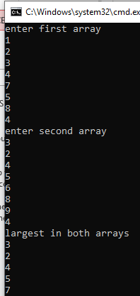

**POST LAB:**

Encryption can be very useful method for protecting sensitive data from intruders. Data is converted into meaningless form by the usage of a given key and it is converted back to original form by utilizing the key again when required. You need to design an encryption\decryption application.

Example:

Inputs: Text: hello world , Key: 3 Outputs: Encrypted text: khoor zruog , Decrypted text: hello world

Note: 1. Use only character arrays. 2. String Library functions are not allowed. 3. Make separate functions for encryption and decryption and write down the main function as well to make the code interactive. 4. Usage of temporary arrays is prohibited. Both encryption and decryption should be performed on original array.

• Write a C++ code for the above problem.

#include<iostream>

#include<cstring>

using namespace std;

void encryption(char a[],int b)

{

for(int i=0;i<b;i++)

a[i]=a[i]+3;

}

void decryption(char a[],int b,char e[])

{

if(strcmp(a,e))

for(int i=0;i<b;i++)

a[i]=a[i]-3;

}

int main()

{

char x[100],c[100]={'\0'};

int l,m;

cout<<"Enter Text: ";

cin.getline(x,100,'\n');

l=strlen(x);

for(int j=0;j<l;j++)

c[j]=x[j];

while(1)

{

cout<<"Enter key 2 for descrypt and 3 for encrypt or any number to exit: ";

cin>>m;

if(m==3)

{

encryption(x,l);

cout<<"Encryption Text is: "<<x<<endl;

}

else if(m==2)

{

decryption(x,l,c);

cout<<"decrypted Text is: "<<x<<endl;

}

else

break;

}

return 0;

}

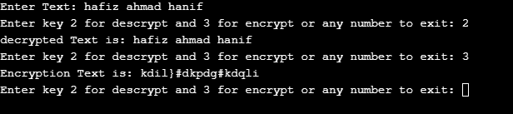

**Conclusion:**

In this lab we learn how to use character arrays and string array and how they apply.